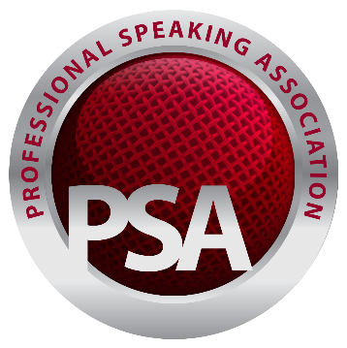

Fellowship of the Professional Speaking Association (PSA) UK and Ireland

Guide and Template for Client Testimonials

The Professional Speaking Association is the community for professional speakers and trainers across the UK and Ireland. Fellowship is the most qualified level of membership. In support of an application to become a Fellow, you have been asked to provide a reference and testimonial.
Please complete the final section of this template and return it to the Speaker who requested it. Many thanks for your support in upholding the Professionalism of PSA Fellowship.

Name of the Speaker / Trainer requesting your reference | Click or tap here to enter text.
About the Client (to be completed by the Applicant)
Client Contact name | Click or tap here to enter text.
Client organisation | Click or tap here to enter text.
Client Contact role | Click or tap here to enter text.
Client email address | Click or tap here to enter text.
Client preferred phone number | Click or tap here to enter text.
About the Speaking / Training Session(s) Provided (to be completed by the Applicant)
Date(s) of the speaking or training delivered | Click or tap here to enter text.
Session or programme title(s) | Click or tap here to enter text.
Session delivery duration and audience size | Click or tap here to enter text.
Invoice number(s) or reference(s) for this client | Click or tap here to enter text.
Fee(s) paid for the Speaking / Training delivered | Click or tap here to enter text.
Client Feedback on the Speaking / Training Services Received (to be completed by the Client)
What would you say about the quality of the services received? Please comment on content and delivery | Click or tap here to enter text.
What would you say about working with this Speaker / Trainer (including the contact you had with them before and after delivery)? | Click or tap here to enter text.
Would you be happy to book the Speaker / Trainer again and/or recommend them to others? | Click or tap here to enter text.
Date of Testimonial | Click or tap here to enter text.

Many thanks for your support in upholding the Professionalism of PSA Fellowship

Document Version: 1.0
Date: 29th August 2023
Author: Sarah Fox / Sue Evans, Fellows Community Presidents at time of writing.

